**Communication: Theory and Types**

3. Explain the process of communication. Discuss the components of communication.

**Ans:** The process of communication requires at least two individuals-a sender who wants to share a message or information and a receiver of that message or information. In this process, the sender encodes(articulates) the information or message and sends it to the receiver by means of a channel or medium. Then the receiver decodes it- interprets its meaning- and responds to it by sending an appropriate feedback to the sender. The process of communication is only successful when the message is understood by the receiver and the sender gets a response/feedback from the receiver.

The main components involved in the process of communication are -

(i) Sender: The sender is the source of communication, who initiates the process to communicate thoughts,ideas,emotion or information and sends the message via a medium, which is accessible to the receiver.

(ii) Encoding: It refers to the articulation of the sent message through words, symbols, pictures. gestures etc,to make the receiver understand the message. This form or medium may be verbal or nonverbal depending on the context and also the communication skills available to the sender and the receiver.

(iii)Message: It is the information, thought or feeling that the sender feels has to be communicated to the receiver for a particular purpose.

(iv) Medium: It is the channel through which the message travels from the sender to the receiver. The choice of the medium is determined by encoding. It is a system of signs and codes that are shared both by the sender and the receiver.

(v) Receiver: The message reaches the goal/ the receiver and has to perform the reverse function of the sender. The receiver has to decode the message and comprehend it to complete the process of communication.

(vi) Decoding: It refers to the interpretation of the message by the receiver. Decoding is dependent on the ability of the receiver to understand or make use of the medium. The process of decoding can also be affected by interferences, such as noise.

(vii) Feedback: The process of communication is completed only when the receiver sends a feedback or response to the sender. Feedback is the reversal of the earlier process of communication and the receiver becomes the sender and vice-versa.

4. What is a formal channel of communication? Discuss its advantages and disadvantages.

**Ans**: In the formal channel of communication, the message is transmitted through predefined routes of an organization. Such a channel of communication has clarity regarding the roles and relationships of the members of the organization. It is a structured and systematic movement of messages or information that determines the efficiency and operational ability of an organization. It passes through prescribed channels and maintains formal relations between the participants.

The advantages are-

(i) A set of predetermined rules and regulations are followed which help in increasing efficiency.

(ii) It provides more credible information as it involves a designated authority and also allows further reach without distortion of information.

(iii) Filtering of information and messages in the formal channel ensures that only the most important ones get transmitted. It also ascertains that the proper message reaches the proper person so that action can be taken accordingly.

The disadvantages are-

(i)There is a certain lack of cordiality due to excessive formality involved in this channel of communication.

(ii) It is time consuming as there are several levels involved through which a message has to pass before it reaches its destination.

(iii)The formal channel of communication is expensive as it involves a lot of written communication and documentation of records also makes the process expensive.

5. What is grapevine? Discuss its advantages and disadvantages.

**Ans:** Grapevine refers to the informal channel of communication which is non-hierarchical in nature and does not follow any predefined official pattern or communication channels.It flows in all directions.It is oral in nature and is undocumented. It is personal and results from the social nature of human beings to communicate with each other.

The advantages are-

(i) It is speedy and a spontaneous channel of communication as there are no obstacles of the hierarchical structure.

(ii) Since it is in oral form and does not require documentation, it is inexpensive and fast in transmission of messages.

(iii) The informality of the channel allows prompt feedback.

The disadvantages are-

(i) The information available from grapevine cannot be verified and the information is not reliable.

(ii) It is difficult to trace the exact source of information.

(iii) It can be used to spread misinformation and to harm someone’s reputation.

6. Discuss the differences between formal and informal channels of communication.

**Ans:**

|  |  |
| --- | --- |
| **Formal Communication** | **Informal Communication** |
| 1. It is mostly used in official settings. | 1.It is used in mostly unofficial settings. |
| 1. The transmission of messages is slower because of the hierarchical structure. | 2. The transmission of messages is faster because of the absence of obstacles or hierarchical structure. |
| 1. It is used to mainly fulfill certain tasks. | 3. It stems from a basic human desire to communicate and relate to one another. |
| 1. The origin of the message can be verified easily as it is documented. | 4. The origin of the message cannot be verified as most often it is anonymous in nature. |
| 1. Message is accurate and authentic. | 5. Message might be inaccurate and inauthentic. |
| 1. Flows in a fixed direction and structure. | 6. Flows in every possible direction. |

1. What is upward communication? Discuss its advantages and disadvantages.

**Ans:** Communication which flows from the lower order of the hierarchical structure of an organization to the superiors is termed as upward communication. It is relatively less common because it has to travel upward and employees are often unsure if their reactions or feelings would be understood. E.g. complaints and grievances, suggestions etc.

Its advantages are-

(i) Provides feedback from the lower levels to the higher levels of authority.

(ii) Reporting an ongoing job and seeking interventions if necessary.

(iii) Reporting of grievances and complaints.

Its disadvantages are-

(i) Misrepresentation of employees or distortion of communication can take place. Favorable feedback will be allowed while unfavorable ones will be held back.

(ii) Subordinates are often in awe or fear of their superiors which might affect the communication process.

(iii) Superiors often do not like to be criticized and therefore upward communication might be discouraged.

1. What is downward communication? Discuss its advantages and disadvantages.

**Ans:** The flow of communication in an organisation that involves a hierarchical structure is usually downward. The authority is the source of any information and it travels to other designated members of the organisation who will implement the communication. This type of flow of information ensures that the important activities of an organisation are carried out properly and also instill a sense of acceptance of authority. E.g. memos, letters, meetings, speeches etc.

Its advantages are-

(i) Specific instructions can be given to employees about a given job.

(ii) Provide feedback to the people lower down the hierarchy who have carried out any information communicated earlier.

(iii) Helpful to motivate and encourage employees for better performance.

Its disadvantages are-

(i) Distortion of facts and information communicated can happen as the message travels lower down the hierarchy.

(ii) It is a time-consuming process as information has to travel through a series of intermediaries.

(iii) It is authoritative by nature and often involves ego hassles and resistance among the subordinates.

1. What is lateral communication? Discuss its advantages and disadvantages.

**Ans:** Communication which flows among individuals situated within the same level of an organization is termed as lateral or horizontal communication. The persons concerned could be from the same department or spread across departments but holding the same position or rank.

Its advantages are-

(i) It allows for better sharing of ideas and better coordination within the workplace.

(ii) Facilities faster communication.  
(iii) There is a better possibility of receiving reviews and leads to a faster decision- making process.

Its disadvantages are-

(i) It can lead to rivalry or competition among individuals.

(ii)The lack of authority may lead to less assertiveness of communication.

1. What is diagonal or cross-wise communication? Discuss its advantages and disadvantages.

**Ans:** Communication which occurs across the hierarchy with people from different levels interacting with each other but outside the limits of reporting relationships set up by their position or ranks. E.g. if the vice president of marketing communicates with a sales representative or vice- versa then it is diagonal communication.

Its advantages are-

(i) It improves coordination and understanding.

(ii) The interaction is usually informal.

(iii)Faster communication leads to less delay.

Its disadvantages are-

(i) The bypassing of reporting relationships and the hierarchy might create misunderstanding.

(ii) Excessive use of diagonal communication may lead to interference and chaos.

1. What is a communication model?

**Ans:** When the communication process is represented through a line or a picture, it is called a communication model. In other words, pictoral presentation of communication process is known as communication model.

1. Discuss Aristotle’s model of communication with special reference to its five basic elements.

**Ans:** Aristotle’s model of communication emphasised the importance of the role of the speaker in communication and is focused more on public speaking or communication rather than interpersonal communication. It is based on five elements i.e. the speaker, speech, occasion, audience and effect. The role of the speaker is important as he has to be prepared for his speech before speaking publicly. The speaker should understand the audience and should be able to mould the minds of the audience. The speaker has to prepare a speech while keeping in mind the occasion and has to have some effect on the audience. Here, feedback is not important.

Ocassion

1. Discuss Shanon and Weaver’s model of communication.

**Ans:** The Shanon-Weaver model of communication states that communication is a process which includes the sender, encoding, channel, decoding, receiver and feedback. Along with it, there is also the factor of noise which affects the channel of communication and can lead to miscommunication by the receiver.

Sender: It is the person who wishes to communicate the message.

Encoding:It is the process through which the message is changed into signals.

Channel: The channel is the medium through which the message is communicated.

Decoding: The receiver decodes the message on receiving it and has to do so in a manner in which it was encoded to understand it properly.

Receiver: The receiver gets the message and usually sends a feedback too.

Noise: It is the disturbance that affects the channel of communication. Noise often results in inaccuracy of messages sent and received.

Feedback: Feedback is important in order to make sure that the message has been well received.

Sender

Encoder

Channel

Decoder

Receiver

Noise

Feedback

Information Source

Transmitter

Reception

Destination

1. Discuss Berlo’s SMCR Model of Communication.

**Ans:** Berlo’s model of communication is based on Shanon-Weaver’s model of communication. In this model, he gave importance to the factors which affect the process of communication and also emphasizes on the encoding and decoding of messages. According to Berlo, encoding takes place before the message is sent and decoding before the message is received by the receiver. It operates on the SMCR model- S= Sender, M=Message, C=Channel, R=Receiver. Each of these components are affected by many factors.

Sender is the source or origin of the message and the message is affected by five factors- communication skills, attitudes, knowledge, social system, and culture and these factors are the same for the receiver too.

Message is the information or substance sent by the sender to the receiver. It is again affected by the factors of content, elements, treatment, structure and code.

Channel is the medium to send messages. Berlo says that all our sensory organs in fact act as channels of communication.

Receiver is the person to whom the message is sent and who ultimately gets it.

The sender and receiver should have the same factors affecting them and must be in sync for

effective communication to take place. The message might not have the same effect as intended if the receiver and sender are not similar.The receiver should also have good listening skills.

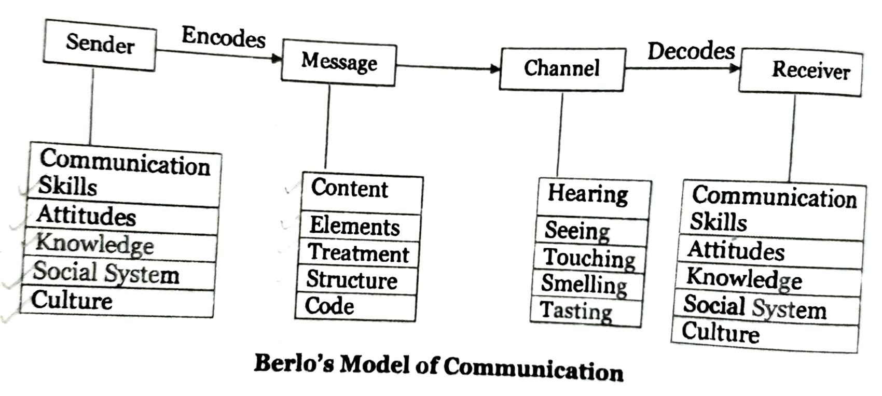

1. Discuss Osgood and Schramm’s Model of Communication.

**Ans:** Osgood and Schramm’s model of communication is a circular model and is an extension of Shanon and Weaver’s model of communication. It is a continuous process, which doesn’t begin or end somewhere. The sender and the receiver are interchangeable in this process and are engaged in an ongoing process of encoding, decoding and interpreting. The receiver should be able to decode and interpret the message received properly from the sender and at the same time send proper feedback. The process of interpretation is also dependent on many forces like socio-cultural differences, education, background, values etc.

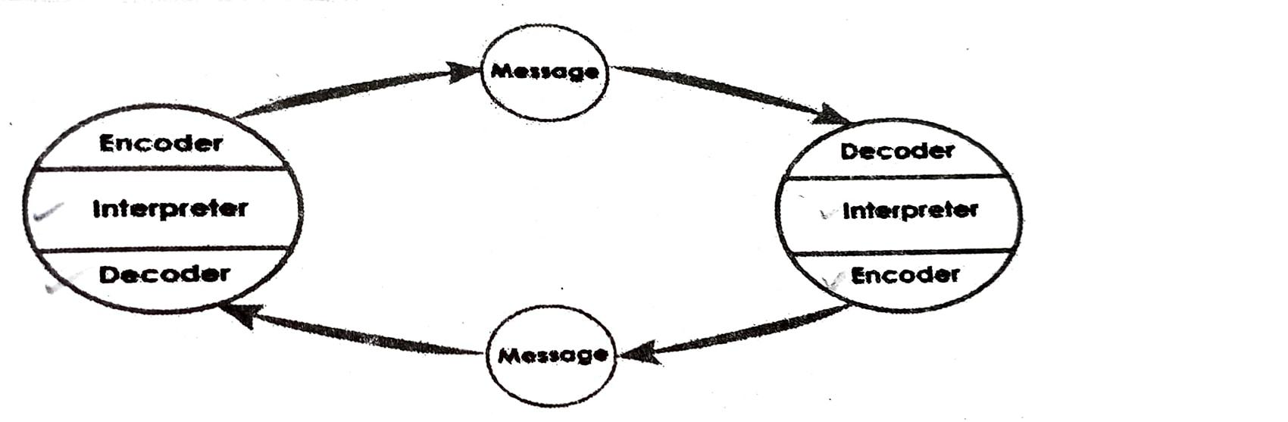

1. Discuss the Helical Model of Communication.

**Ans:** The Helical model is based on a simple helix which gets bigger and bigger as it grows. It is a non-linear model and is always moving forward. It is a flexible process of communication because it is a free flowing system of communication. Like a helix, the communication process starts slowly at the bottom with a chosen few people and gradually spirals to include a large number of people. It is a model which is dependent on the past and evolves with the passage of time. The helical model, is small at the bottom and with the passage of time it starts growing bigger. As each spiral is dependent on the lower loops to move up, so also the process of communication is dependent on the earlier levels to progress further.

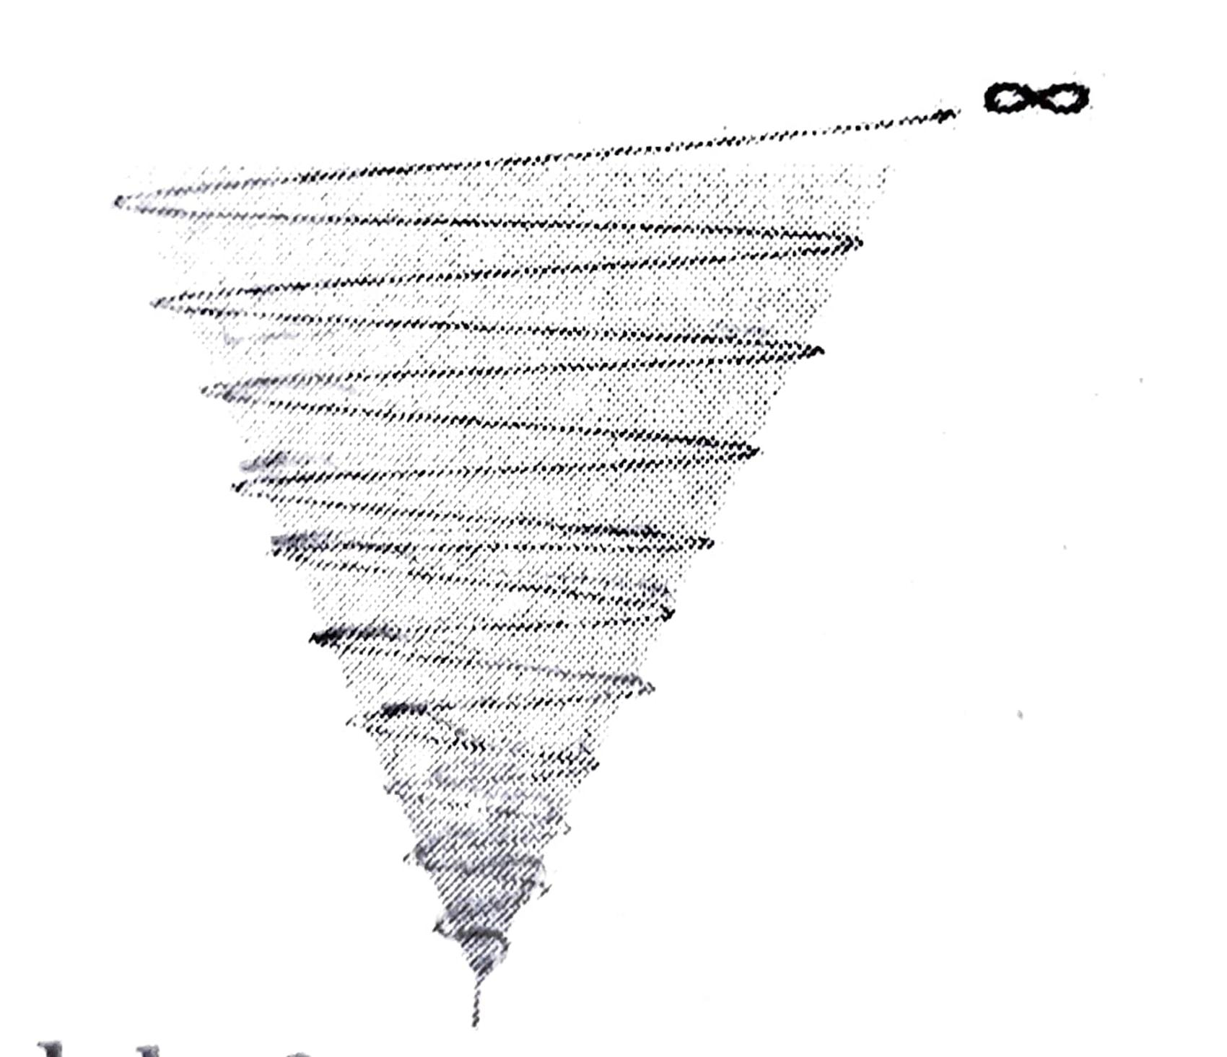

1. Discuss the various theories of communication.

**Ans:** (i) Rhetorical Theory: This theory studies all types of communication like interpersonal, intrapersonal, social and mediated communication and is focused on the manner in which symbols are used in communication The communicator in rhetorical communication gives thought to the message and persuades the receiver to achieve an intended outcome. Rhetorical theory includes verbal, non-verbal, visual elements of communication and encompasses even aspects like dress, appearance, sports, art and culture.

(ii)Semiotic Theory: It focuses on language. The sign is arbitrary and it depends on interpretation. This theory studies the ways in which people use signs, their understanding of the manner in which signs are interpreted and categorized along with the means through which the signs are transmitted to others.

(iii) Phenomenological Theory: This theory emphasizes that each person is actively involved in the construction of his/her/their own world and each person’s interpretation of the world around constructs his/her/their personality. The way a person understands the various occurrences and circumstances around them, determines the manner in which the person’s behavioral patterns also guide their approach to the world.

(iv) Cybernetic Theory: It is based on the concept that the basic function of communication is to process information through which the environment in which one lives can be controlled. Effective communication can take place when two persons interacting with each other understand the background factors that influence each other’s interactions and simultaneously adapt themselves to the circumstances for better communication.

(v) Socio-Psychological Theory: This theory focuses on individual cognition and behavioral characteristics in the process of communication. Theorists believe that there is a distinct connection between cause and effect and study of individual behavior can predict the ways in which they accommodate or adapt to particular communication situations.

(vi) Socio-Cultural Theory: This theory assesses the contribution that society has towards individual development. The interactions that people have with the culture that they live in have an influence on their process of communication.It is a system that looks into both the potential for individual growth and understanding as also the external factors that can influence knowledge and skills.

(vii) Critical Theory: It is primarily a social theory that works at critiquing and changing society as a whole in contrast to traditional theory oriented only to understanding or explaining it.The hierarchical structures and relations of communities, cultures, societies are questioned to understand the process in which people communicate and process information.

(viii) Systems Theory: It was proposed by Ludwig von Bertalanffy, where he considered human communication as a system.’ Overlying principles of communicative transfer’ and ‘influence of communicative relationships within systems’ are the key areas in this theory.He stressed that all elements in this world are interconnected and this theory studied the interconnectedness of human communication.

(ix) Information Theory: This theory was proposed by Claude Shannon, where he introduced the concept of channel and quantitatively analyzed the transmission of information through a channel. He devised a way to measure the amount of information in a message through an entropy rate. If the amount of information in a message exceeds the information carrying capacity of the channel then communication becomes erroneous, whereas if the amount is below the capacity, then, the information can be retrieved without any error by encoding it in a particular way.